**N26 Task Test Overview**

**Task 1:**

1. Create following fields on contact object
   1. Survey_Date__c as Date field
   2. Language__c as Picklist field
2. To create a batch file go to setup -> Develop -> classes -> New Class and copy the code I have shared you
   1. [batch_surveySendReport](https://github.com/MUSTAFAN26Demo/N26Demo/blob/master/batch_surveySendReport)
3. To initiate the batch class to run for the first time, you need to go to Developer Console and execute the following code,

DateTime currentTime = system.now();

DateTime nextRunTime = currentTime.addminutes(1);

string sch = '0 '+ nextRunTime.minute() + ' ' + nextRunTime.hour() + ' ' + nextRunTime.day() + ' ' + nextRunTime.month() + ' ? ' + nextRunTime.year();

System.schedule('Push Contact Survey', sch, new batch_surveySendReport());

**Task 2:**

1. Create following fields on contact object
   1. Survey_Date__c as Date field
   2. Home_Country__c as Picklist field
2. Create Pricebooks with Names
   1. IT
   2. UK
   3. ES
   4. FR
   5. DE
3. To create a component class go to setup -> Develop -> classes -> New Class and copy the code I have shared you
   1. [contactProductInformationClass.txt](https://github.com/MUSTAFAN26Demo/N26Demo/blob/master/contactProductInformationClass.txt)
4. Before Creating Product, Modify the existing values of Product Family by going to the Product Fields.
   1. Cost per Calendar Month
   2. ATM Fee in other currencies
   3. Card Replacement Cost
5. Create product for each Product Family

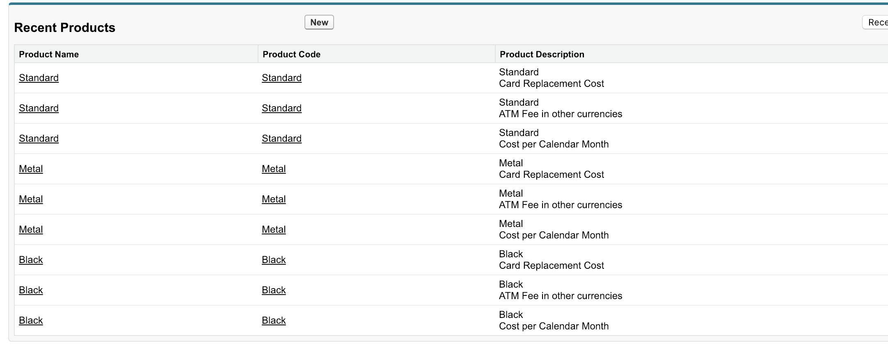

1. Now Create Pricebook Entries based on the document.

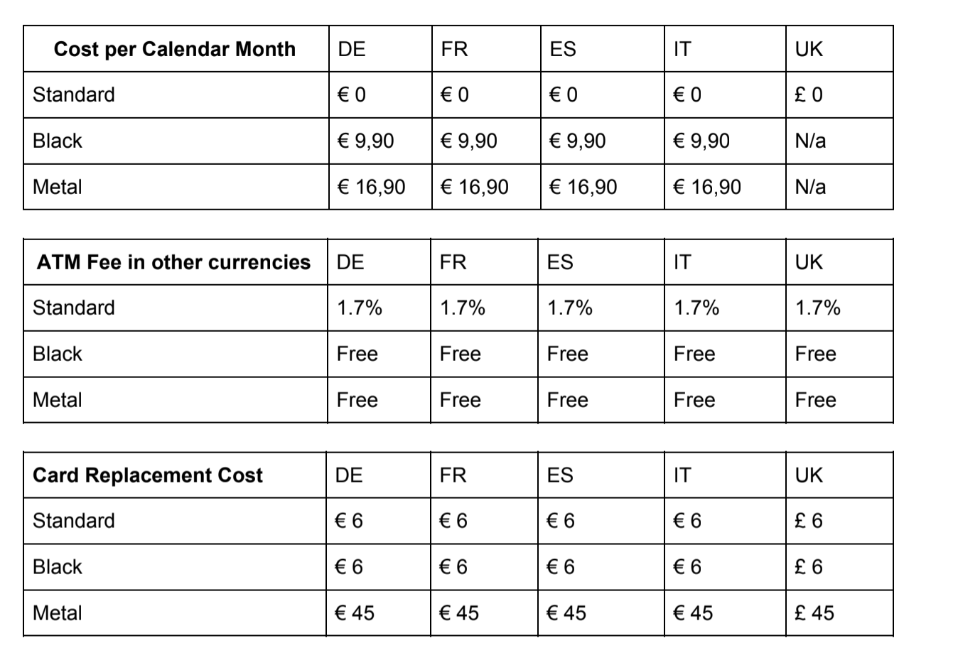

Note: N/a means you don’t need to add entry in that pricebook.

1. To create aura component, you need to go to developer console and click on File -> New -> Lightning Component and write Name as **Contact_Product_Information** and checked on Lightning Record Page checkbox.

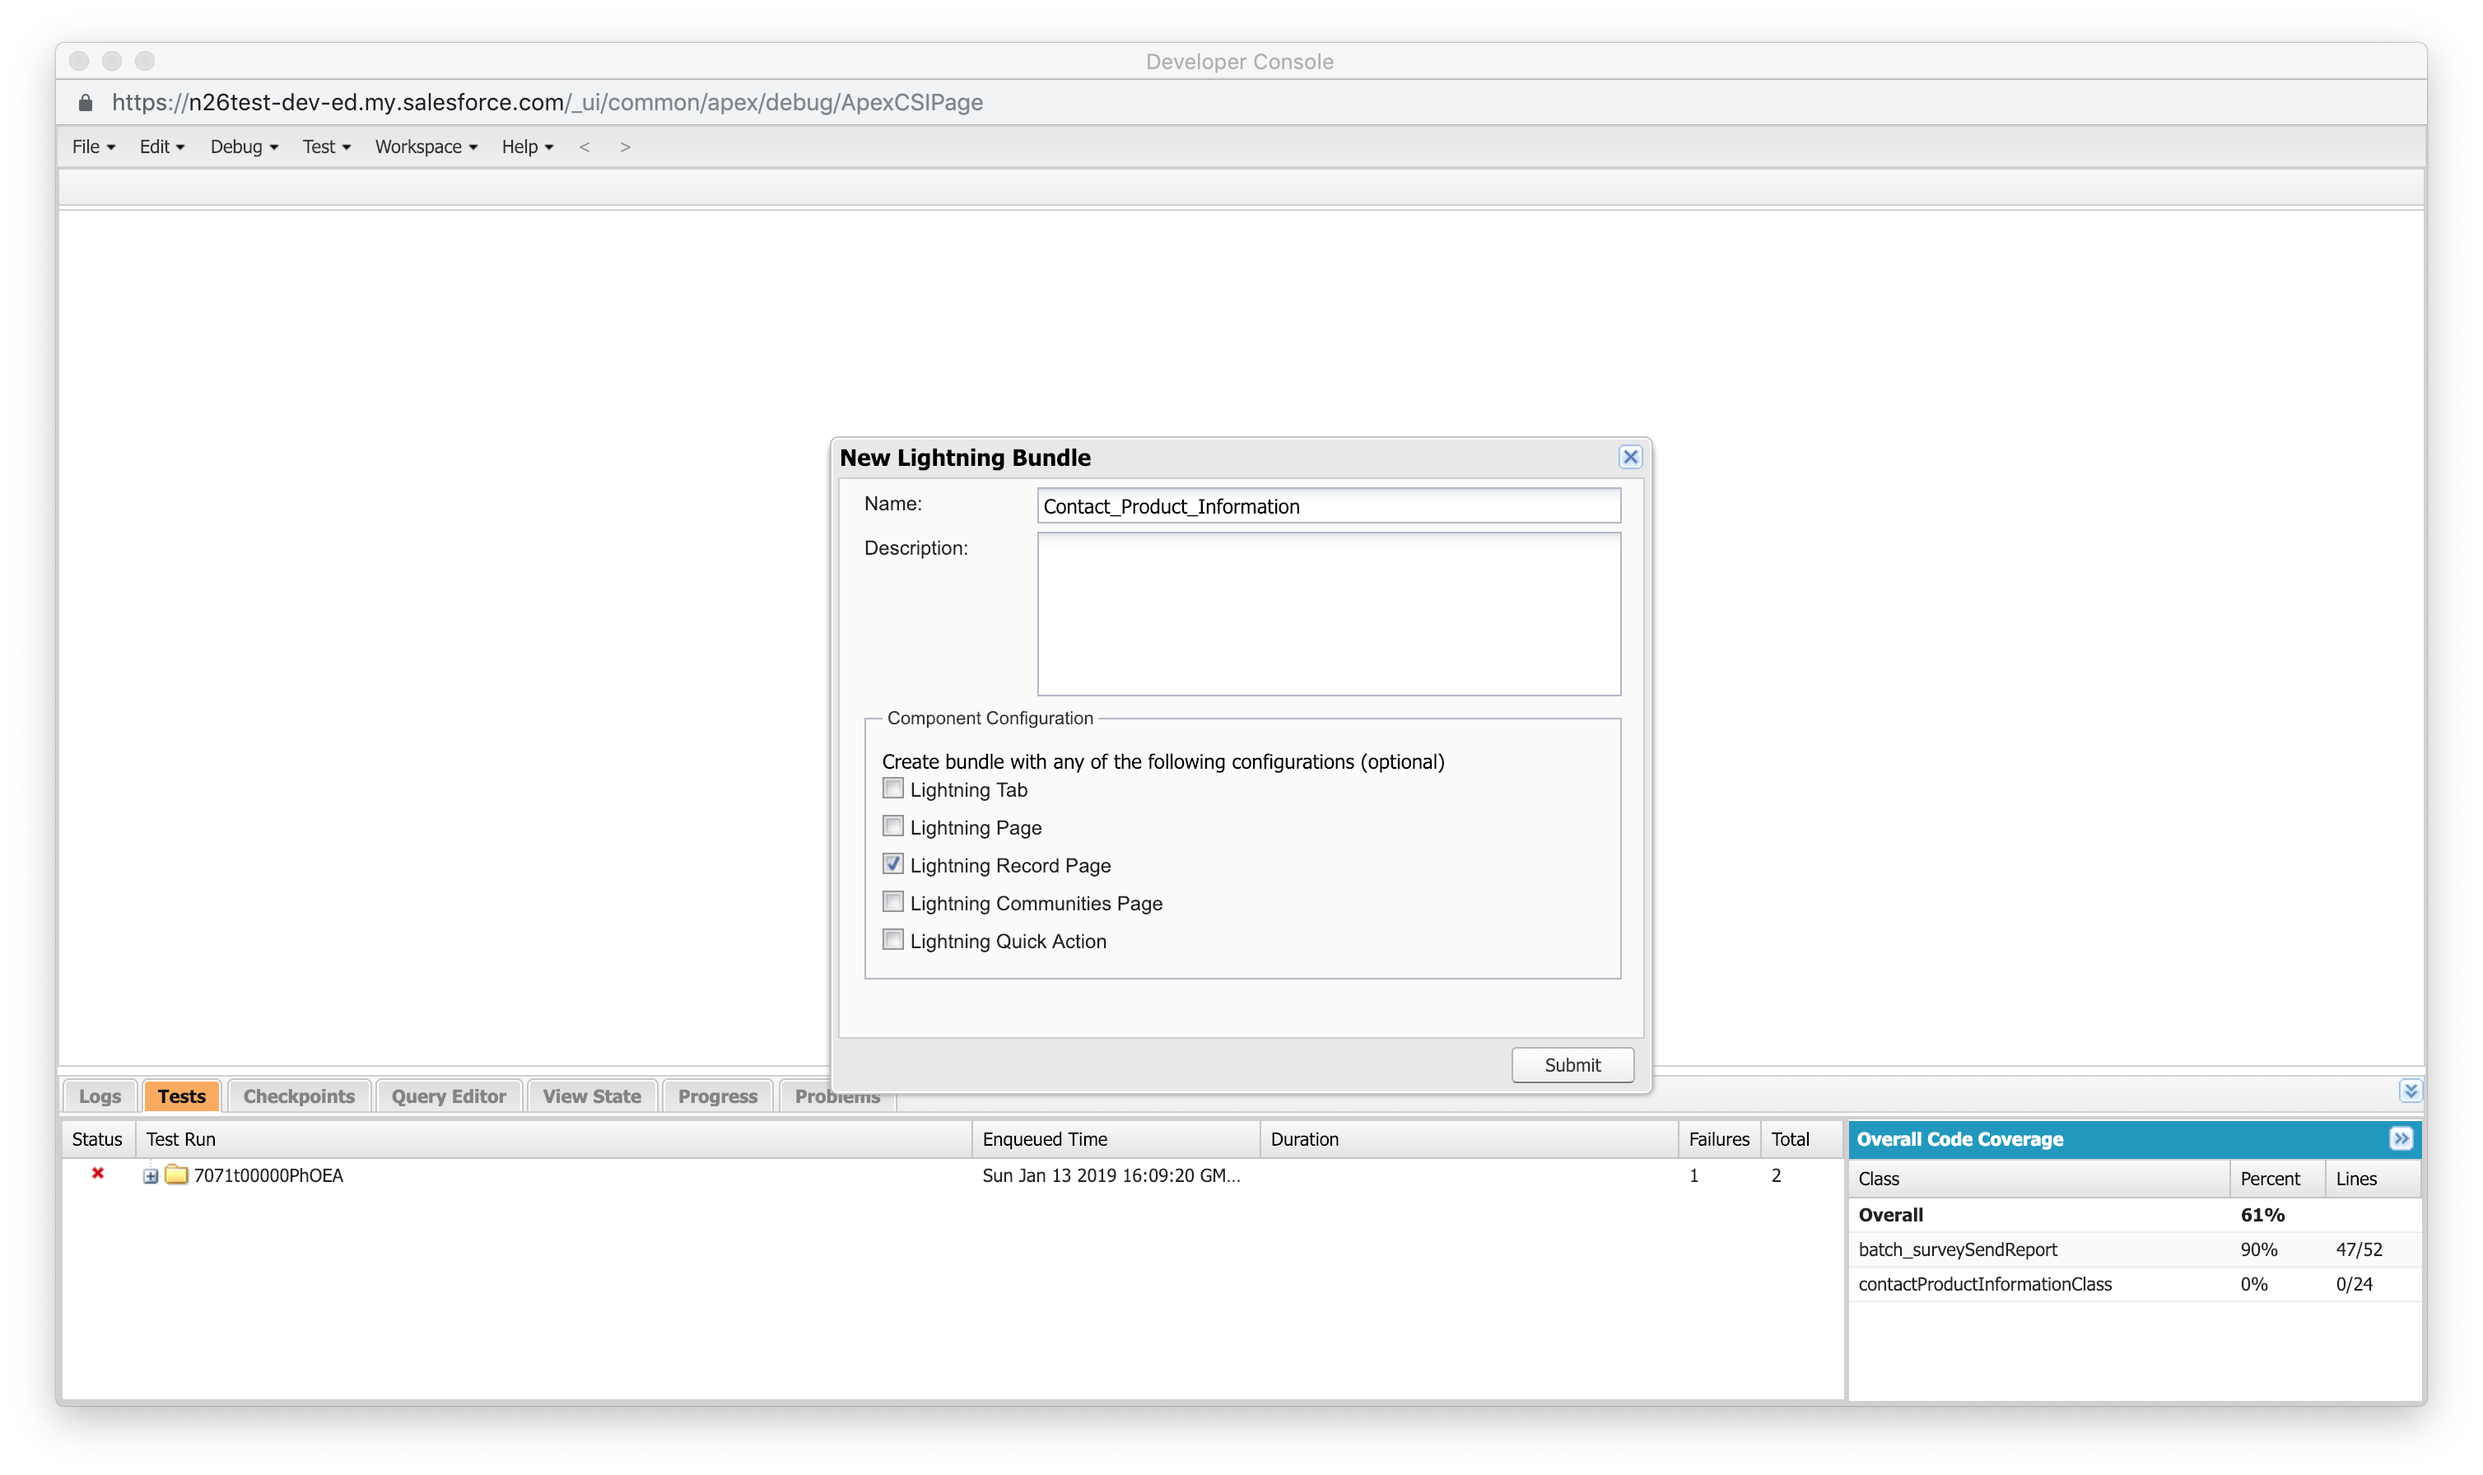

1. Modify the Case Lightning page and add the component there

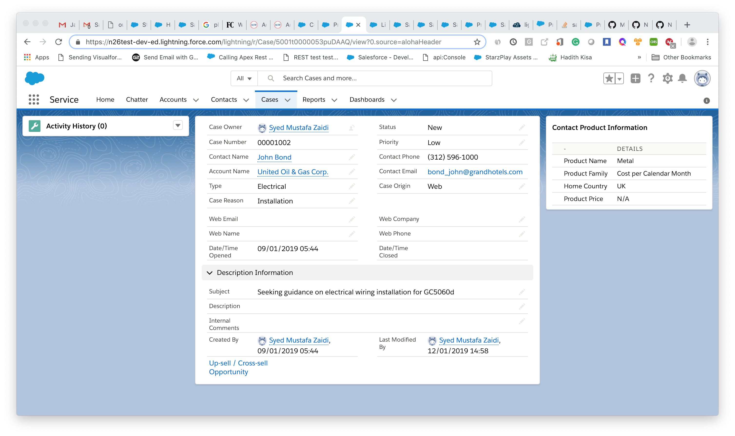

1. Once component is created, copy the code I have shared you into aura component and controller bundle,
2. [Contact_Product_Information.cmp](https://github.com/MUSTAFAN26Demo/N26Demo/blob/master/Contact_Product_Information.cmp)
3. [Contact_Product_InformationController.js](https://github.com/MUSTAFAN26Demo/N26Demo/blob/master/Contact_Product_InformationController.js)

Now you can test the component in your org.